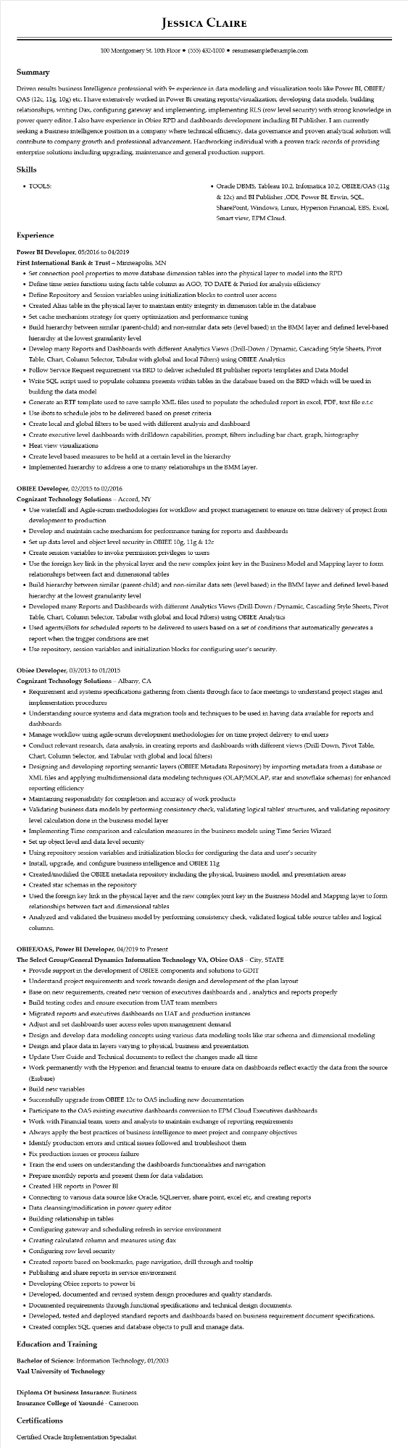
JESSICA CLAIRE
100 Montgomery St. 10th Floor (555) 432-1000⚫ resumesample@example.com
Summary
Driven results business Intelligence professional with 9+ experience in data modeling and visualization tools like Power BI, OBIEE/ OAS (12c, 11g, 10g) etc. I have extensively worked in Power Bi creating reports/visualization, developing data models, building relationships, writing Dax, configuring gateway and implementing, implementing RLS (row level security) with strong knowledge in power query editor. I also have experience in Obiee RPD and dashboards development including BI Publisher. I am currently seeking a Business intelligence position in a company where technical efficiency, data governance and proven analytical solution will contribute to company growth and professional advancement. Hardworking individual with a proven track records of providing enterprise solutions including upgrading, maintenance and general production support.
Skills
• TOOLS:
• Oracle DBMS, Tableau 10.2, Infomatica 10.2, OBIEE/OAS (11g
& 12c) and BI Publisher,ODI, Power BI, Erwin, SQL, SharePoint, Windows, Linux, Hyperion Financial, EBS, Excel, Smart view, EPM Cloud.
Experience
Power BI Developer, 05/2016 to 04/2019
First International Bank & Trust - Minneapolis, MN
• Set connection pool properties to move database dimension tables into the physical layer to model into the RPD
• Define time series functions using facts table column as AGO, TO DATE & Period for analysis efficiency
• Define Repository and Session variables using initialization blocks to control user access
• Created Alias table in the physical layer to maintain entity integrity in dimension table in the database
• Set cache mechanism strategy for query optimization and performance tuning
• Build hierarchy between similar (parent-child) and non-similar data sets (level based) in the BMM layer and defined level-based hierarchy at the lowest granularity level
• Develop many Reports and Dashboards with different Analytics Views (Drill-Down / Dynamic, Cascading Style Sheets, Pivot Table, Chart, Column Selector, Tabular with global and local Filters) using OBIEE Analytics
• Follow Service Request requirement via BRD to deliver scheduled BI publisher reports templates and Data Model
• Write SQL script used to populate columns presents within tables in the database based on the BRD which will be used in building the data model
• Generate an RTF template used to save sample XML files used to populate the scheduled report in excel, PDF, text file e.t.c
• Use ibots to schedule jobs to be delivered based on preset criteria
• Create local and global filters to be used with different analysis and dashboard
• Create executive level dashboards with drilldown capabilities, prompt, filters including bar chart, graph, histography
• Heat view visualizations
• Create level based measures to be held at a certain level in the hierarchy
• Implemented hierarchy to address a one to many relationships in the BMM layer.
OBIEE Developer, 02/2015 to 02/2016
Cognizant Technology Solutions - Accord, NY
• Use waterfall and Agile-scrum methodologies for workflow and project management to ensure on time delivery of project from development to production
• Develop and maintain cache mechanism for performance tuning for reports and dashboards
• Set up data level and object level security in OBIEE 10g, 11g & 12c
• Create session variables to invoke permission privileges to users
• Use the foreign key link in the physical layer and the new complex joint key in the Business Model and Mapping layer to form relationships between fact and dimensional tables
• Build hierarchy between similar (parent-child) and non-similar data sets (level based) in the BMM layer and defined level-based hierarchy at the lowest granularity level
• Developed many Reports and Dashboards with different Analytics Views (Drill-Down/Dynamic, Cascading Style Sheets, Pivot Table, Chart, Column Selector, Tabular with global and local Filters) using OBIEE Analytics
• Used agents/iBots for scheduled reports to be delivered to users based on a set of conditions that automatically generates a report when the trigger conditions are met
• Use repository, session variables and initialization blocks for configuring user's security.
Obiee Developer, 03/2013 to 01/2015
Cognizant Technology Solutions - Albany, CA
• Requirement and systems specifications gathering from clients through face to face meetings to understand project stages and implementation procedures
• Understanding source systems and data migration tools and techniques to be used in having data available for reports and dashboards
• Manage workflow using agile-scrum development methodologies for on time project delivery to end users
• Conduct relevant research, data analysis, in creating reports and dashboards with different views (Drill-Down, Pivot Table, Chart, Column Selector, and Tabular with global and local filters)
• Designing and developing reporting semantic layers (OBIEE Metadata Repository) by importing metadata from a database or XML files and applying multidimensional data modeling techniques (OLAP/MOLAP, star and snowflake schemas) for enhanced reporting efficiency
• Maintaining responsibility for completion and accuracy of work products
• Validating business data models by performing consistency check, validating logical tables' structures, and validating repository level calculation done in the business model layer
• Implementing Time comparison and calculation measures in the business models using Time Series Wizard
• Set up object level and data level security
• Using repository session variables and initialization blocks for configuring the data and user's security
• Install, upgrade, and configure business intelligence and OBIEE 11g
• Created/modified the OBIEE metadata repository including the physical, business model, and presentation areas
• Created star schemas in the repository
• Used the foreign key link in the physical layer and the new complex joint key in the Business Model and Mapping layer to form relationships between fact and dimensional tables
• Analyzed and validated the business model by performing consistency check, validated logical table source tables and logical columns.
OBIEE/OAS, Power BI Developer, 04/2019 to Present
The Select Group/General Dynamics Information Technology VA, Obiee OAS - City, STATE
• Provide support in the development of OBIEE components and solutions to GDIT
• Understand project requirements and work towards design and development of the plan layout
• Base on new requirements, created new version of executives dashboards and, analytics and reports properly
• Build testing codes and ensure execution from UAT team members
• Migrated reports and executives dashboards on UAT and production instances
• Adjust and set dashboards user access roles upon management demand
• Design and develop data modeling concepts using various data modeling tools like star schema and dimensional modeling
• Design and place data in layers varying to physical, business and presentation
.
Update User Guide and Technical documents to reflect the changes made all time
• Work permanently with the Hyperion and financial teams to ensure data on dashboards reflect exactly the data from the source
(Essbase)
• Build new variables
• Successfully upgrade from OBIEE 12c to OAS including new documentation
• Participate to the OAS existing executive dashboards conversion to EPM Cloud Executives dashboards
• Work with Financial team, users and analysts to maintain exchange of reporting requirements
• Always apply the best practices of business intelligence to meet project and company objectives
• Identify production errors and critical issues followed and troubleshoot them
• Fix production issues or process failure
• Train the end users on understanding the dashboards functionalities and navigation
• Prepare monthly reports and present them for data validation
• Created HR reports in Power BI
• Connecting to various data source like Oracle, SQLserver, share point, excel etc, and creating reports
• Data cleansing/modification in power query editor
• Building relationship in tables
• Configuring gateway and scheduling refresh in service environment
• Creating calculated column and measures using dax
• Configuring row level security
• Created reports based on bookmarks, page navigation, drill through and tooltip
• Publishing and share reports in service environment
• Developing Obiee reports to power bi
• Developed, documented and revised system design procedures and quality standards.
• Documented requirements through functional specifications and technical design documents.
• Developed, tested and deployed standard reports and dashboards based on business requirement document specifications.
• Created complex SQL queries and database objects to pull and manage data.
Education and Training
Bachelor of Science: Information Technology, 01/2003
Vaal University of Technology
Diploma of business Insurance: Business
Insurance College of Yaoundé - Cameroon
Certifications
Certified Oracle Implementation Specialist

